**Project 3: Revenue Insights (Hospitality Domain)**

**ABOUT THE PROJECT**

I analyzed and carried out Revenue Insights on a fictional hotel dataset provided by CodeBasics.IO

**TOOLS USED**

Excel

Power BI

**DATASET OVERVIEW**

Wayne Hotels is a large group of hotel Chains, currently operating in multiple big cities. The Manager-Head wants to find out the main causes of losing market share to competitors and consequently, the revenue loss.

**DATA PREPARATION**

I downloaded a copy of the dataset from the codebasics.io website. Once done, I created a copy of the original Excel file and explored the dataset.

I needed to answer the following business questions:

1. What are the main causes of low revenue?
2. Is there any correlation between low average ratings and low occupancy?
3. How much is the difference between the bookings done at the hotel and other platforms?

Once done with exploring the data, I imported the file into the Power BI Power Query editor for data cleaning, transformation, and modeling.

**DATA CLEANING**

1. Created a duplicate copy of all five datasets.
2. Removed irrelevant columns.
3. Made 1st row as headers.
4. Changed the datatype of required columns.
5. Created two new calculated columns – Week No and Day_type.

**DATA MODELING**

Created a Star-Schema Model having 6 relationships in total**.** They are as follows:

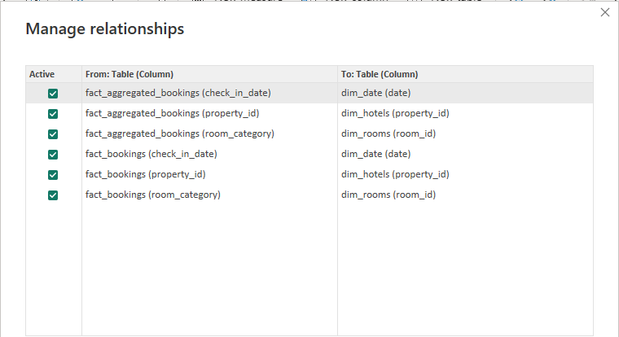

**DATA ANALYSIS**

To analyze the data in the Power BI desktop, I created over 25 DAX measures to enrich my analysis.

They’re

|  |  |  |
| --- | --- | --- |
| 1. ADR (Average Daily Rates) | 9. Average Rating | 17. Occupancy % |
| 1. ADR WoW Change % | 10. Booking % by Platform | 18. Occupancy WoW Change % |
| 1. DSRN (Daily Sellable Room Nights) | 11. Booking % by Room Class | 19. Realization % |
| 1. DSRN WoW Change % | 12. Cancellation % | 20. Realization WoW Change % |
| 1. RevPar (Revenue per available room) | 13. DBRN (Daily Booked Room Nights) | 21. Total Bookings |
| 1. RevPAR WoW Change % | 14. DURN (Daily Utilized Room Nights) | 22. Total Cancelled Booking |
| 1. Revenue | 15. No. of Days | 23. Total Capacity |
| 1. Revenue WoW Change % | 16. No-Show Rate % | 24. Total Checked Out |

The results of the analysis are shown in the report and seek to answer the aforementioned business questions.

**FINDINGS**

1. Between Weekdays and Weekends, there’s only a minuscule difference in the ADR (Average Daily Rates).
2. Hotel properties having a low average rating, also have low occupancy vis-a-vis other properties.
3. The Hotel group is clearly falling behind due to low promotions/offers when compared to those offered by other platforms.

**RECOMMENDATIONS**

Based on my findings, I would recommend that Wayne Hotels:

1. Since the ADR (Avg Daily Rates) is almost stable, that means there's room for dynamic pricing based on occupancy and other metrics.
2. Not much difference in ADR for prices of Weekends and Weekdays, therefore, separate prices can be kept based on day type.
3. Property having a lower Avg rating usually has low occupancy, thus, affecting the hotel biz. Therefore, measures need to be taken at those properties so that customers feel satisfied.
4. There's an opportunity to increase revenue by promotion (e.g., give extra discounts/offers such as gifts/complimentary night stays, etc.) at checkout on direct online booking at the hotel's own website (vs Offers given by other platforms). This would substantially increase the bookings done directly at hotel or its website.